Phoenix Biomass Gasifier Stove
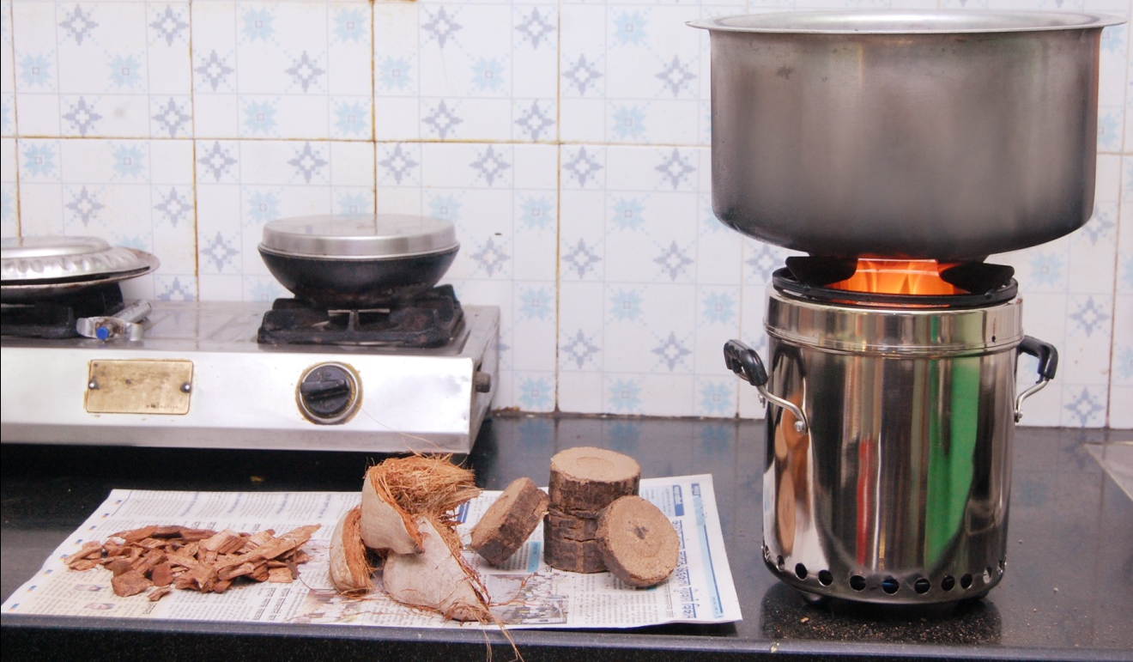
- Stainless steel outer and inner chamber
- Fuel: Wood chips, pellets, biomass briquettes, small twigs, wood chunks, rice husk, coconut shell etc.
- Charcoal produced as a bye product

We are engaged in manufacturing of Biomass briquettes & portable Biomass Gasifier Stove which is specifically designed to use either loose or compressed crop waste as well as wood. The Biomass Gasifier Stove is more efficient and produces hardly any smoke. This is achieved by burning the fuel using a controlled supply of air that produces gas which then rises to meet 'secondary' air causing the fuel to burn more thoroughly. This ensures that the fuel burns more efficiently and that heat is transferred to the pots more quickly which allows a meal to be cooked in around 15 minutes with minimal smoke pollution.

Biomass Gasifier stove has radically improved the lives of farming families in the regions where it has been sold. It reduces the cost of cooking and heating by 50% whether it is using crop waste or wood, and it significantly reduces levels of indoor air pollution and smoke. The innovative biomass stove can actually shrink your LPG / electricity bill drastically and simultaneously reduce the level of carbon dioxide emission. It`s actually an environmental and energy-saving stove. The range is also widely acknowledged all over for its features.

The Problem being addressed
• 60% households in India still rely on wood and biomass as cooking fuels using primitive, smoky and inefficient chulhas (Census, 2001)
• Every year 500,000 women and children in India die prematurely due to long term exposure to smoke in the kitchen (WHO, 2002)
• Subsidy on LPG and kerosene is not sustainable in the long term
(Planning Commission Committee, 2005)
Solution :
Small-scale micro-gasifiers offer good opportunities for the use in cook-stove for domestic heating, because they can
• Cleanly burn the Producer gas in mainly smoke-free combustion (unlike conventional burning
of solid fuel)
• Provide a steady hot flame shortly after ignition (no waiting, as with charcoal)
• Have high fuel-efficiency due to complete combustion of the fuel (little smoke)
• Be operated batch-fed over extended periods without attention (no tending of fire)
• Utilise a wide variety of solid biomass fuels, even inexpensive often discarded small
biomass residues, that other stoves cannot easily handle (no stick-wood)

