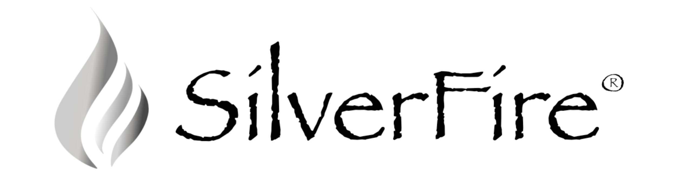
FOR IMMEDIATE RELEASE

CONTACT: Todd Albi
777 Washington Street
Eugene, OR 97401
(541) 222-9212
www.SilverFire.us

SilverFire Begins Global Operations in Eugene, Oregon

EUGENE, OREGON – SilverFire®, a leading clean cook stove organization, today announced it has begun operations at its’ headquarters in Eugene, Oregon. SilverFire expects to ship tens of thousands of advanced technology clean cook stoves globally for commercial and humanitarian use in 2013.

SilverFire has established global operations at its worldwide headquarters at 777 Washington Street in Eugene, Oregon. In addition to a distribution center, SilverFire will operate a retail showroom at the location where consumers can come and see the newest developments in clean cook stove technology. “SilverFire is dedicated to showcasing the most advanced stove technology on the planet”, said Todd Albi, President of SilverFire. “We are entering a new era of clean burning stove technology that is unprecedented in the industry, and SilverFire will utilize these new advanced technologies in upcoming consumer products” said Mr. Albi, who has been instrumental in developing clean stove technologies.

About SilverFire®

Everyday over 3 billion people in the developing world cook food on open fires or inefficient cook stoves fueled by coal or solid biomass, jeopardize human health, contribute to household & community air pollution, and impact environmental devastation by depleting forests and increasing soil erosion. 4 million premature deaths occur every year due to exposure from toxic smoke emissions. Consequently women and children are disproportionately impacted by household air pollution.

SilverFire’s mission as a leading designer of clean cook stoves is to protect humans from the health and environmental impact of inefficient cook stoves and fuel use. SilverFire® is headquartered in Eugene, Oregon. More information can be found at our web site at www.SilverFire.us

###

