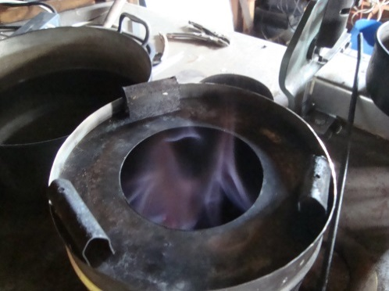
5 mm sewage- mud/wastepaper into The Peko Pe , same color during the whole process about 50 minutes
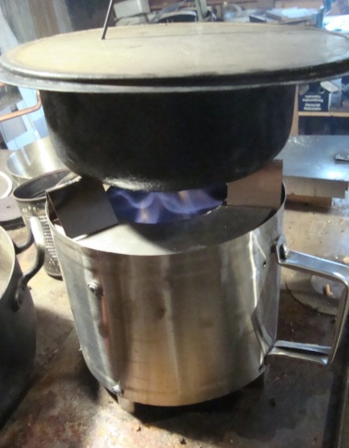

WTB 3 liter, 600 gr. sewage-mud/wastepaper 18 minutes from 8 to 100 C˚
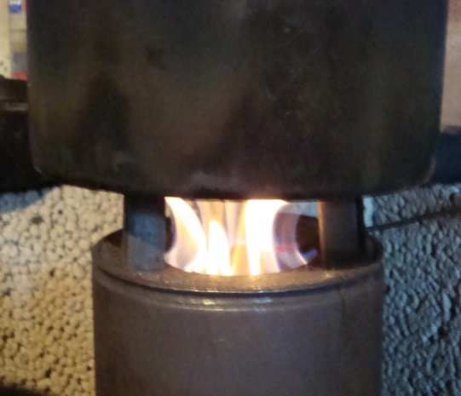

WTB 3 liter, 600gr wood-pellets 13 minutes from 10 t0 m100 C˚

