ECO-KALAN-C & 3 VARIATIONS TO PROVIDE SEPARATE PRIMARY AND SECONDARY AIRFLOWS
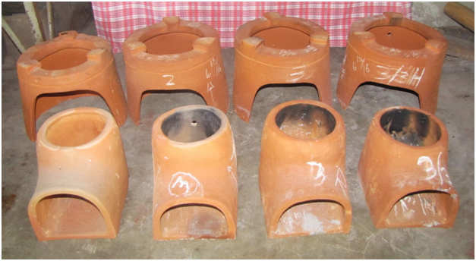
FRONT: COMBUSTION CHAMBERS BACK: KALANS
ECO-KALAN-C (3AF, -3”Arc, Holes CC) ECO-KALAN-C (3AF, -3”Arc, -3”Chimney, Holes K)
↓ ↓
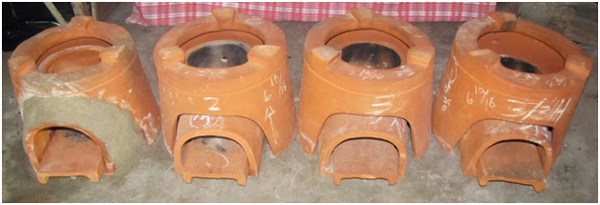
↑ ↑
ECO-KALAN-C (1AF, current production) ECO-KALAN-C (2AF, -3Arc)
LEFT TO RIGHT:
https://plus.google.com/photos/113101643783889350444/albums/5917422628027620641?partnerid=gplp0

1. ECO-KALAN-C (1AF)—CURRENT PRODUCTION
WHEN IN USE, SPACE BETWEEN KALAN & CHAMBER IS INSULATED WITH ASH. ONE OPENING FOR COMBINED PRIMARY AND SECONDARY AIR. HEIGHT OF POT SUPPORT IS 11/16 INCH.

WBT1 PHOTOS FOR ECO-KALAN-C (TIME TO BOIL WATER TEST USING 18.75L WATER IN 33L POT)
https://plus.google.com/photos/113101643783889350444/albums/5917419040022346465

RESULTS:
TIME TO BOIL: 31 minutes;
WEIGHT OF FIREWOOD USED: 1.70kg (3.00 kg - 0.15kg unburned wood - 1.00kg unused wood - 0.15kg charcoal)

2. ECO-KALAN-C (3AF, -3”Arc, Holes CC)
3 AIRFLOWS –THROUGH THE FRONT OPENING OF THE COMBUSTION CHAMBER; SPACE BETWEEN THE KALAN &
CHAMBER; AND THE 3 HOLES (11/16 INCH IN DIAMETER) AT THE BACK AND L & R SIDES OF THE COMBUSTION CHAMBER. FRONT ARC IS REDUCED BY 3 INCHES AT WET CLAY STAGE. HEIGHT OF POT SUPPORTS IN THE KALAN IS REDUCED TO 9/16 INCH FROM 11/16 INCH IN THE ECO-KALAN-C CURRENTLY PRODUCED.

HCC BURN PHOTOS FOR ECO-KALAN-C (3AF, -3”Arc, Holes CC)
https://plus.google.com/photos/113101643783889350444/albums/5917353577656369889

WBT2 PHOTOS FOR ECO-KALAN-C WITH 3 HOLES IN COMBUSTION CHAMBER (3AF, -3”Arc, Holes CC)
https://plus.google.com/photos/113101643783889350444/albums/5917506299230383505?partnerid=gplp0

RESULTS:
TIME TO BOIL: 46 minutes
WEIGHT OF FIREWOOD USED: 1.80kg (3.00 – 0.10kg unburned wood – 1.0kg unused wood – 0.10kg charcoal)

3. ECO-KALAN-C (2AF, -3”Arc) NO HOLES
NO HOLES IN KALAN OR CHAMBER. 2 AIRFLOWS – COMBINED PRIMARY & SECONDARY AIR AT FRONT OPENING; AND AIR BETWEEN KALAN & CHAMBER FOR COOLING. FRONT ARC REDUCED BY 3 INCHES AT WET CLAY STAGE. HEIGHT OF POT SUPPORTS IS 9/16 INCH.

#3 BURN PHOTOS FOR ECO-KALAN-C (2AF, -3” Arc) NO HOLES
https://plus.google.com/photos/113101643783889350444/albums/5916668974891855425?partnerid=gplp0

WBT3 PHOTOS FOR ECO-KALAN-C (2AF, -3” Arc) NO HOLES
https://plus.google.com/photos/113101643783889350444/albums/5917449980290005009

RESULTS:
TIME TO BOIL: 41 minutes
WEIGHT OF FIREWOOD USED: 1.75kg (3.00 – 0.10kg unburned wood – 1.00kg unused wood – 0.15kg charcoal)

4. ECO-KALAN-C (3AF, -3” Arc, -3” Chimney, Holes K)
HAS 3 AIRFLOWS – THROUGH THE FRONT OPENING OF THE CHAMBER; THE SPACE BETWEEN THE KALAN & CHAMBER; AND THE 3 HOLES IN THE KALAN WHICH ARE DIRECTLY ABOVE THE TOP OPENING OF THE CHAMBER. THE 3 HOLES IN THE KALAN ARE 11/16 INCH IN DIAMETER. BOTH FRONT ARC AND THE VERTICAL PART (CHIMNEY) OF COMBUSTION CHAMBER ARE REDUCED BY 3 INCHES AT WET CLAY STAGE.

3-3HK BURN PHOTOS FOR ECO-KALAN-C (3AF, -3” Arc, -3” Chimney, Holes K)
https://plus.google.com/photos/113101643783889350444/albums/5917343754406158945

WBT4 PHOTOS FOR ECO-KALAN-C (3AF, -3” Arc, -3” Chimney, Holes K)
https://plus.google.com/photos/113101643783889350444/albums/5917500318029135809

RESULTS:
TIME TO BOIL: 57 minutes
WEIGHT OF FIREWOOD USED: 2.20kg (3.00 – 0.20kg unburned wood – 0.40kg unused wood – 0.20kg charcoal)

