Methods of Substantial Turn-down in the TLUD Wood Gas Cook Stove
By Kirk Harris
kgharris@sonic.net
May 12, 2014

Acknowledgement
Thank you to Dr. Ron Larson and Dr. Paul Anderson for their extensive advice, input, and encouragement during my efforts to explore turn-down capability in natural-draft, micro-gasification, TLUD type cook stoves. They acted as my advisors in the development of the new turn-down Method 1 described below and have helped to clarify for me how TLUDs work and why the new turn-down methods are effective. They have encouraged me to present my findings to date so that others can try similar tests. All information is in the public domain. I’d also like to thank Reg Harris for his help editing this document.
I have named my test stoves, which use the techniques described below, the Wonderwerk stoves. The name Wonderwerk comes from Wonderwerk Cave in South Africa, an archeological site that is producing evidence of controlled use of fire by early humans.
Overview
Natural-draft, TLUD wood gas cooking stoves, though efficient at high power levels, allow the flame to cool and go out when attempting the low power levels that are needed for simmering food. A TLUD stove with efficient turn-down capability would use less fuel than the current practice of moving the pot to use only part of a high-power flame.
The four methods described below keep the flame hot during turn-down and also assure a flame presence. My test TLUD stoves can be adjusted freely between high and low power levels without producing smoke.
An added bonus of maintaining a flame presence can be immediate self re-ignition if the flame goes out, though this has so far not been reliable.
Background
The current method of turn-down in a natural draft TLUD is to restrict the primary air intake. This does provide limited turn-down, but fails to provide the low power levels desired for simmering, and so is only part of the answer. Some versions of the TLUD stove have addressed the turn-down problem by adding early secondary air through holes drilled into the side of the reactor chamber about midway between the grate and the secondary air entrance. Introducing air in this manner can allow some turn-down but with limited control, and it also burns up the char near the holes, which limits useful char production if this is a goal of the user.
Two principles for efficient turn-down
The two basic principles which have allowed me efficient turn-down of a natural draft TLUD are to keep the flame hot and to maintain a flame presence during turn-down. This I did by providing a supporting heat and flame source. The two methods that I have found to do this are:
- The char method keeps the top surface of the char and the flame close together. The flame heats the char and some of the char burns adding its heat to support the flame. This process also maintains a flame presence. The char may be raised to the flame or the flame lowered to the char.
- The pilot flame method maintains a small pilot flame beneath the secondary flame, 2.5 cm. below in the test stove. This pilot flame will keep the secondary flame hot and maintain flame presence during turn-down.
Four new TLUD turn-down methods
The four methods I have found of attaining a low power flame are described below. Method 1 came first, and the other three were found by observing tests of Method 1. Method 1 has received the most testing and method 2 has received some testing. Methods 3 and 4 have received very limited testing; however, they did provide turn-down during that limited testing. In my view, the pilot flame method, Method 2, is the most promising. It is simpler and cheaper to build and operate than the other methods, and holds more potential for retrofitting turn-down into existing stoves and stove designs. It has not attained as low a power level as Method 1, but it is adequate for simmering (I measured it at 3.3:1, but this is as yet unconfirmed by others). All of the methods have produced a smokeless flame at all useful power levels.

The standard TLUD—see Diagram A
A standard TLUD burns the wood gas separately from the solid fuel. This arrangement allows efficient high power flames, but only minimal turn-down before the secondary flame goes out.

The secondary flame extinguishes if too much turn -down is attempted.

Wood gas emerges from the char/fuel stack having been produced at the migratory pyrolysis front. The pyrolysis front will continue to produce wood gas/smoke if the secondary flame is extinguished. Methods 1 and 2, by maintaining flame presence, have often provided immediate re-ignition to help alleviate this problem, but this has not yet become reliable. More work is needed to make self re-ignition reliable.

Fuel

Secondary air exterior entrance

The primary air must be adjustable to get the stoves limited turn-down ability

Diagram A: Standard TLUD

Method 1--A hot char support method—see Diagram B (This method is used in the Wonderwerk TLUD-ES (early secondary) wood gas test stove which was introduced at ETHOS 2014.

This method moves the low power flame down to the char level. For low power settings it introduces early secondary air from an inlet(s) just beneath the secondary air inlet(s), directing it straight down the inner wall of the reactor chamber. When this early secondary air reaches the char, it turns inward and supports combustion of the combustible gases. Placing the early secondary flame this close to the char burns a very small amount of the char, which maintains flame presence and keeps the early secondary flame hot.
This method is more complicated than the others, but achieves very low power levels. Power levels are controlled by adjusting the three air streams, so all three air streams --primary, early secondary and secondary--must be adjustable.
Because of its downward flow the early secondary air will follow the char level as it drops. As it descends the air is heated by the fire and may become buoyant before reaching the char. If so it will turn inward and support combustion. When this happens the stove functions like the pilot flame-supported Method 2 described below, so turn-down is still possible, though more limited. Low power settings heat the descending air slowly, so it can descend further to reach the char where the lowest power flames are possible. The early secondary air is not pre-heated because it would become buoyant sooner, reducing the depth of its descent.

Low power
High power

The early secondary air makes an early secondary flame near the char, heating the surface char. A small amount of the char burns, adding its heat to the flame and maintaining a flame presence.

Fuel

The primary, early secondary and secondary air all need to be adjustable to get maximum turn-down.

Diagram B: Method 1 Char-supported method
Method 2--The pilot flame support method—see Diagram C (This method was first used in the Wonderwerk TLUD-ESP (early secondary pilot) wood gas test stove)

This method uses multiple pilot flames below the secondary flame. I achieved this in the Wonderwerk TLUD-ESP by drilling six 3/16”holes around the reactor wall 2.5 cm. beneath the secondary air entrance. These holes inject early secondary air, which forms pilot flames. This supporting pilot flame arrangement keeps the secondary flame hot and maintains flame presence during turn-down.
The big advantages of this system are that it is simple to build and use, it is low cost, it is unaffected by the fuel level, it has the potential for easily retrofitting existing stoves, and it requires that only the primary air be adjustable. The secondary air controls have been eliminated because they are not needed, and because making only one adjustment is simpler for the cook than making two or three. This method produces a smokeless, low-power secondary flame and does not burn any of the char. This method makes the stove more resistant to going out in a wind gust and can even allow the secondary flame re-ignite if it is blown out and if at least one pilot flame survives.
Early secondary air makes a pilot flame at each of the early secondary air inlet holes. These pilot flames support the secondary flame during turn down by keeping it hot and maintaining a flame presence.

Some of the rising wood gas ignites forming the pilot flames. Unburned wood gas continues up to the secondary flame.

Fuel
This exterior air entrance now supplies air for both the secondary flame and the early secondary pilot flame.

The primary air must be adjustable. For this method it is the only adjustment needed for turn-down.

Diagram C: Method 2 pilot flame supported method
Method 3--A hot Char-support method—see Diagram D
This method supports the secondary flame by raising the char surface up to the top of the reactor. Placement of the char close to the secondary flame causes some of the char to burn, adding its heat to the fire and maintaining a flame presence.
For this method to work, some mechanism would be needed to gradually raise the char up to the flame as the char level drops. My preliminary tests using a full load of fuel showed me that the method works until the char level drops to a level where it can no longer support the flame.

The char and fuel are raised to the top of the reactor and keep the secondary flame hot. This allows the flame to survive turn-down. No early secondary air or pilot flame are required for this method.

Fuel

Some device is needed to keep moving the char up to the flame as the fuel stack is consumed, and the char surface drops.

Primary air is adjustable

Diagram D: Method 3 Char-supported method

Method 4--A hot Char-support method—see Diagram E

This method is a modification intended to simplify Method 1. It moves the low power flame down to the surface of the char by directing early secondary air downward from air inlets just below the secondary air inlets. Some secondary air is allowed in to burn any wood gas that the early secondary flame missed. The benefit of this system is that it requires only one adjustment instead of three.
I have been asked why the air is able to descend in the reactor. First, the air is directed downward by the inlet. It is directed close to the inside of the reactor wall so as not to clash with the flame going up the middle. Second the air descends because of buoyancy. The fire gases, being very hot, are very low density and light weight whereas the in-coming air is cool relative to the fire, meaning it is denser and heavier. Gravity pulls the heavier air down, displacing the lighter fire gases, which rise, buoyed up by the air.
Holes allow secondary air in to burn what the early secondary flame missed.
The high power flame is higher in the reactor.
During turn-down the early secondary air supports an early secondary flame near the char, heating the char surface. As in Methods 1 and 3 some of the char burns, adding its heat to the flame and maintaining a flame presence. The hot char keeps the flame hot during turn-down.

Fuel
The secondary and early secondary air, are not controlled.

The primary air must be adjustable for turn-down

Diagram E: Method 4 Char-supported method
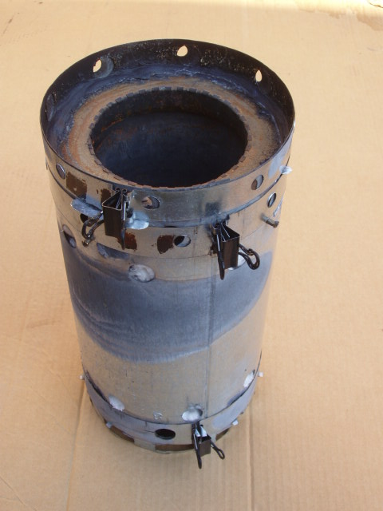
This photo shows a Wonderwerk TLUD-ES test stove that uses Method 1 for turn-down. It is shown without the combustor. The three metal straps wrapped around the stove body allow each air stream to be adjusted separately by squeezing the spring clamp and rotating the strap to adjust the holes sizes. The shadow of the early secondary air entrance into the reactor is just visible. The walls of this stove are insulated as seen through the extra holes in the stove body. These holes are left over from an earlier experiment and are no longer in use.

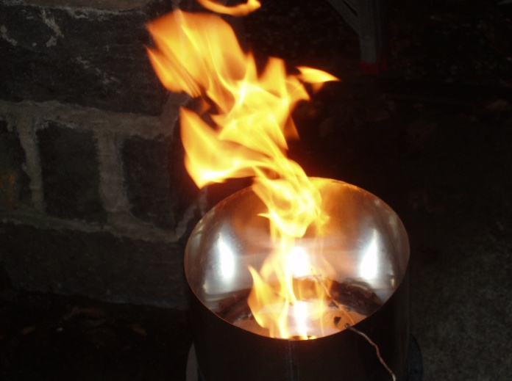
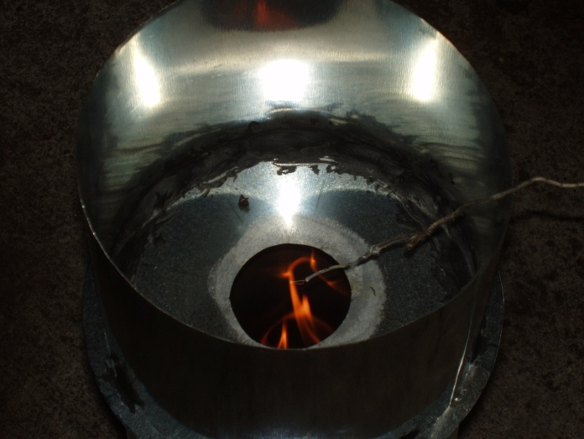
These photos show the Wonderwerk TLUD-ESP test stove using the pilot supported Method 2 for turn-down. The stove is not insulated. The upper photo shows a high power flame and the lower photo shows low power flame (The low power flame looks smaller than it actually is because reflections from the metal caused the automatic camera to reduce the light level.) Both flames were stable and burning for at least five minutes before the photos were taken and neither is making visible smoke. The twig looking thing is a thermocouple. The high power flame temperature varied from 1600F to 1800F and the low power flame from 1400F to 1500F. The fuel is hardwood pellets. I have measured a turn down ratio of 3.3:1, but this is as yet unconfirmed by other testers.

Summary
Lowering the power level of a natural draft TLUD wood gas cook stove requires that the flame be kept hot throughout turn-down, and that flame presence be maintained. To do this, a supporting heat and flame source is needed. This source can be provided by placing the char surface or a wood gas pilot flame directly beneath the main flame. Hot char support can obtain lower power levels than pilot flame support. Both methods achieve power levels that are excellent for simmering food and will burn with a smokeless flame at all levels. The pilot flame supported Method 2 is much cheaper and simpler to build and operate, and so may be more useful for retrofitting an existing stove or stove design with substantial turn-down capability.

