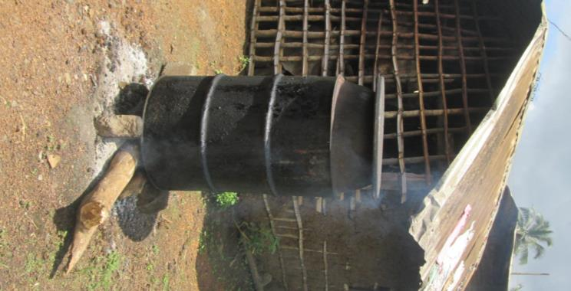
Figure 1: first step of processing palm oil - cooking in a big drum
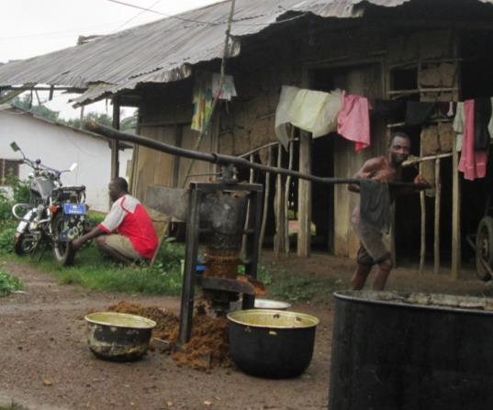
Figure 2: second step of milling the palm fruits
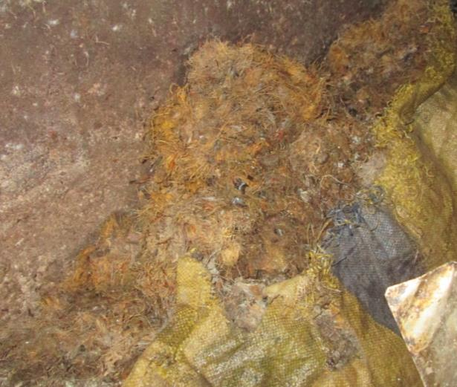
Figure 3: the waste produced is completely dry, consisting of seed kernels and dried fiber

