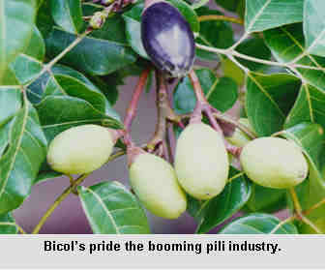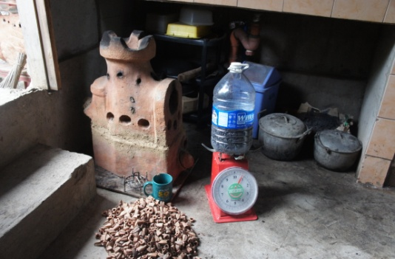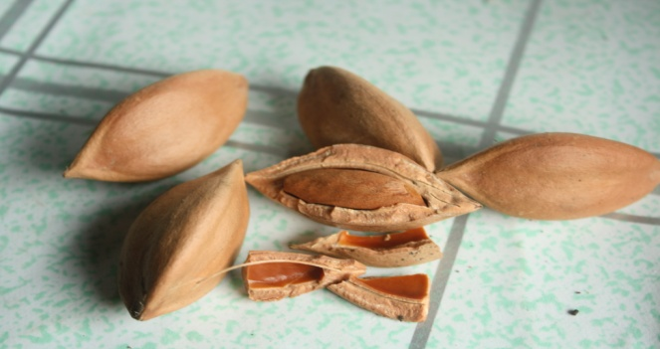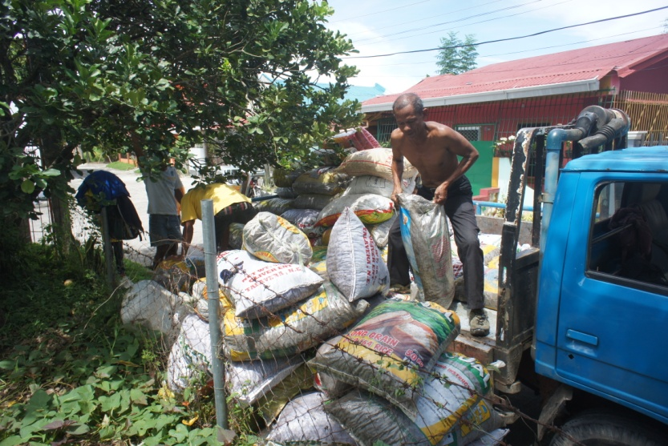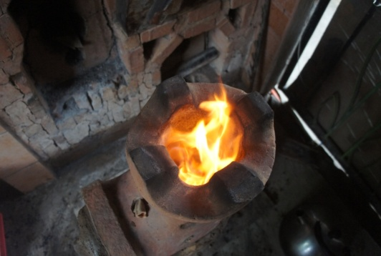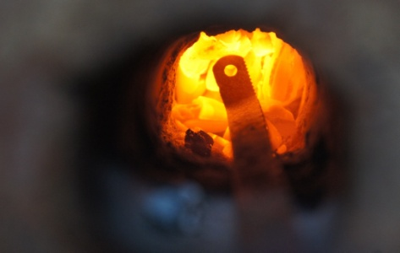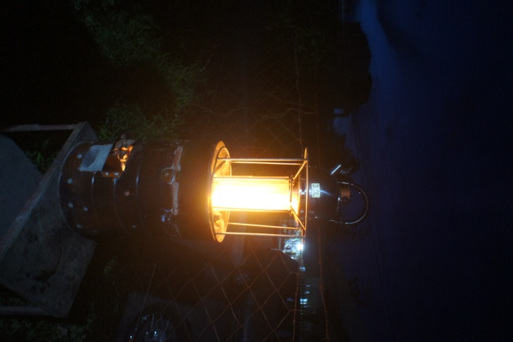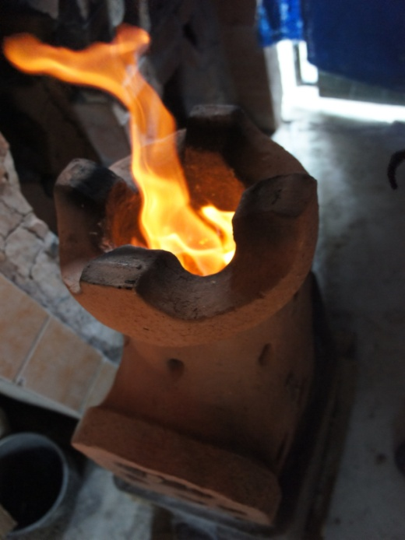

In 2013, I started using pili shells in my Holey Roket Stove in a TLUD mode. And finally on September 2015 i built the PapaBrick Stove which operates both in TLUD and as a rocket. Going further, inspired by the Stove Tech Lantern, I fixed with my a lantern on top. And it was very satisfying.

Photo source all the rest of the photos on this page: Jed Guinto

Photo source: http://www.pcaarrd.dost.gov.ph/home/ssentinel/index.php?option=com_content&view=article&id=1615&Itemid=41

Pilinut (canarium ovatum) is an endemic species of my place in the Bicol Region. The shell is very hard and dense and the shape is perfect for gasifier stoves (top photos). On September 2015, we hauled 4 tons of the shells from a farm. There we found more than 6 tons more underutilized. There are more dumps of the shells in my province possibly just rotting.