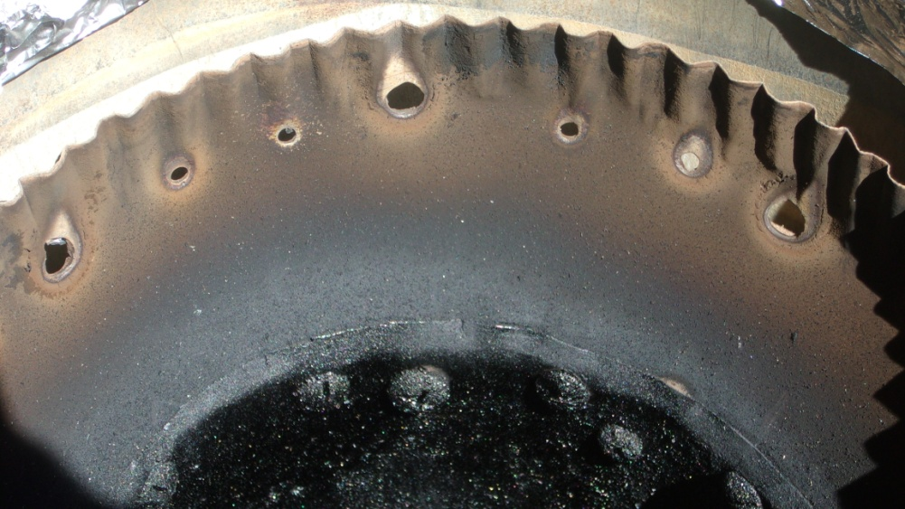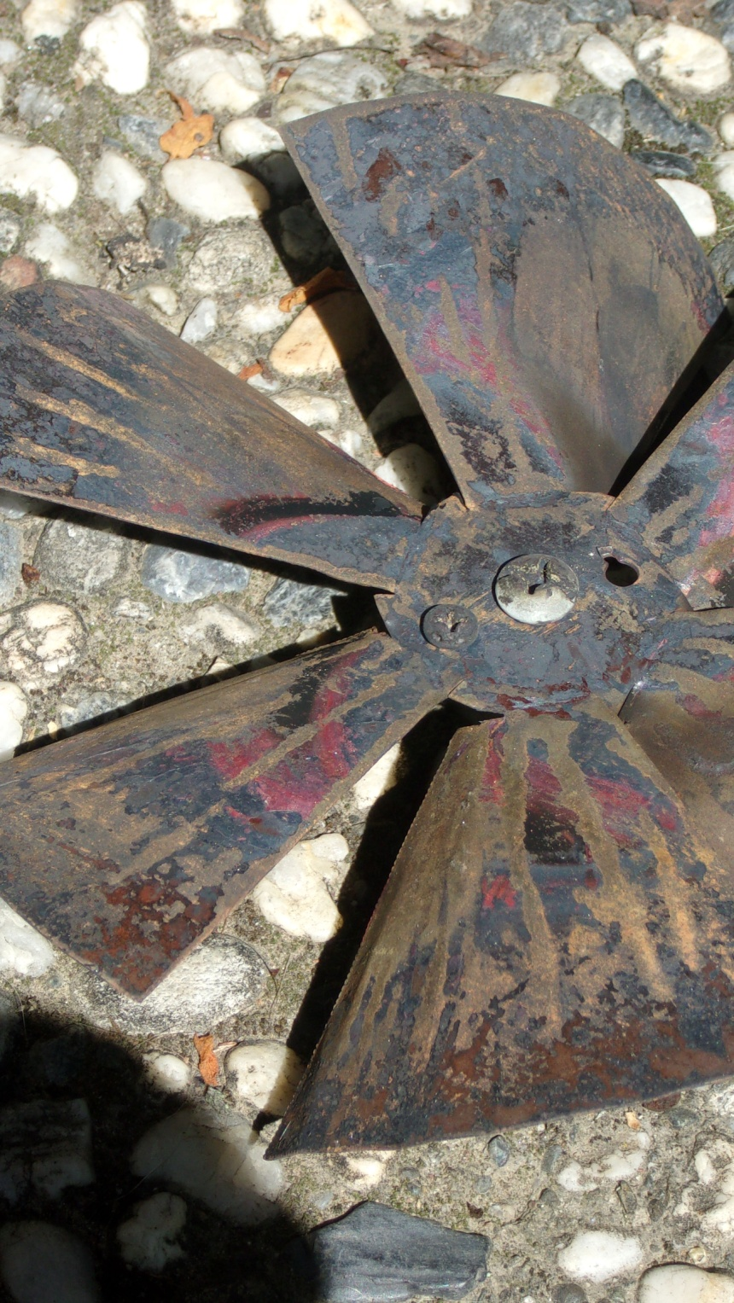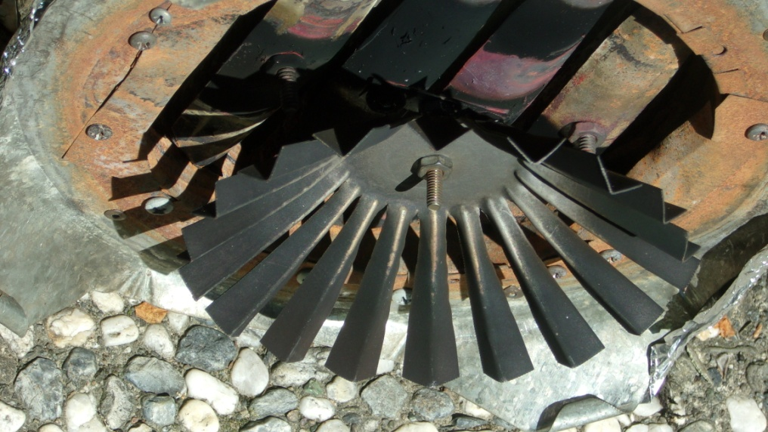

The pilot flame holes with small connecting holes to help re-light any pilot that goes out. Also the creosote problem is visible. Burning the char for a couple of minutes clears this. The chamber is wide enough so there is a space between the wall and the wick.

The stationary fan which swirls the flame now has cuts near the center so the edge of the blades can be curved down to open more space between the blades.

The device I am calling the wick attaches to the bottom of the combustor so the cook doesn’t have to deal with it separately. The tips of the wick’s “legs” must be below the pilot flames to keep the flame above the wick. Holes in the chamber walls or flame below the wick may hurt the turn-down capability.