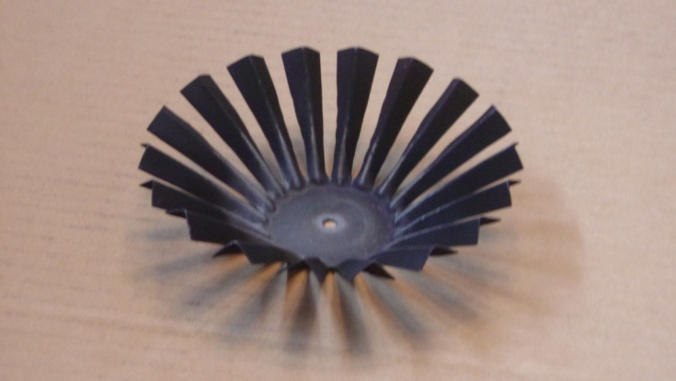

The Wick

The wick gives the low power flame a stable place to settle. Wood gas rises around the outside of the wick (entering the pilot flames) and through the slits. The gas rising through the slits is fed air from the secondary air supply and combusts. This combustion is supported by the pilot flames which rise up the top side of the wick.

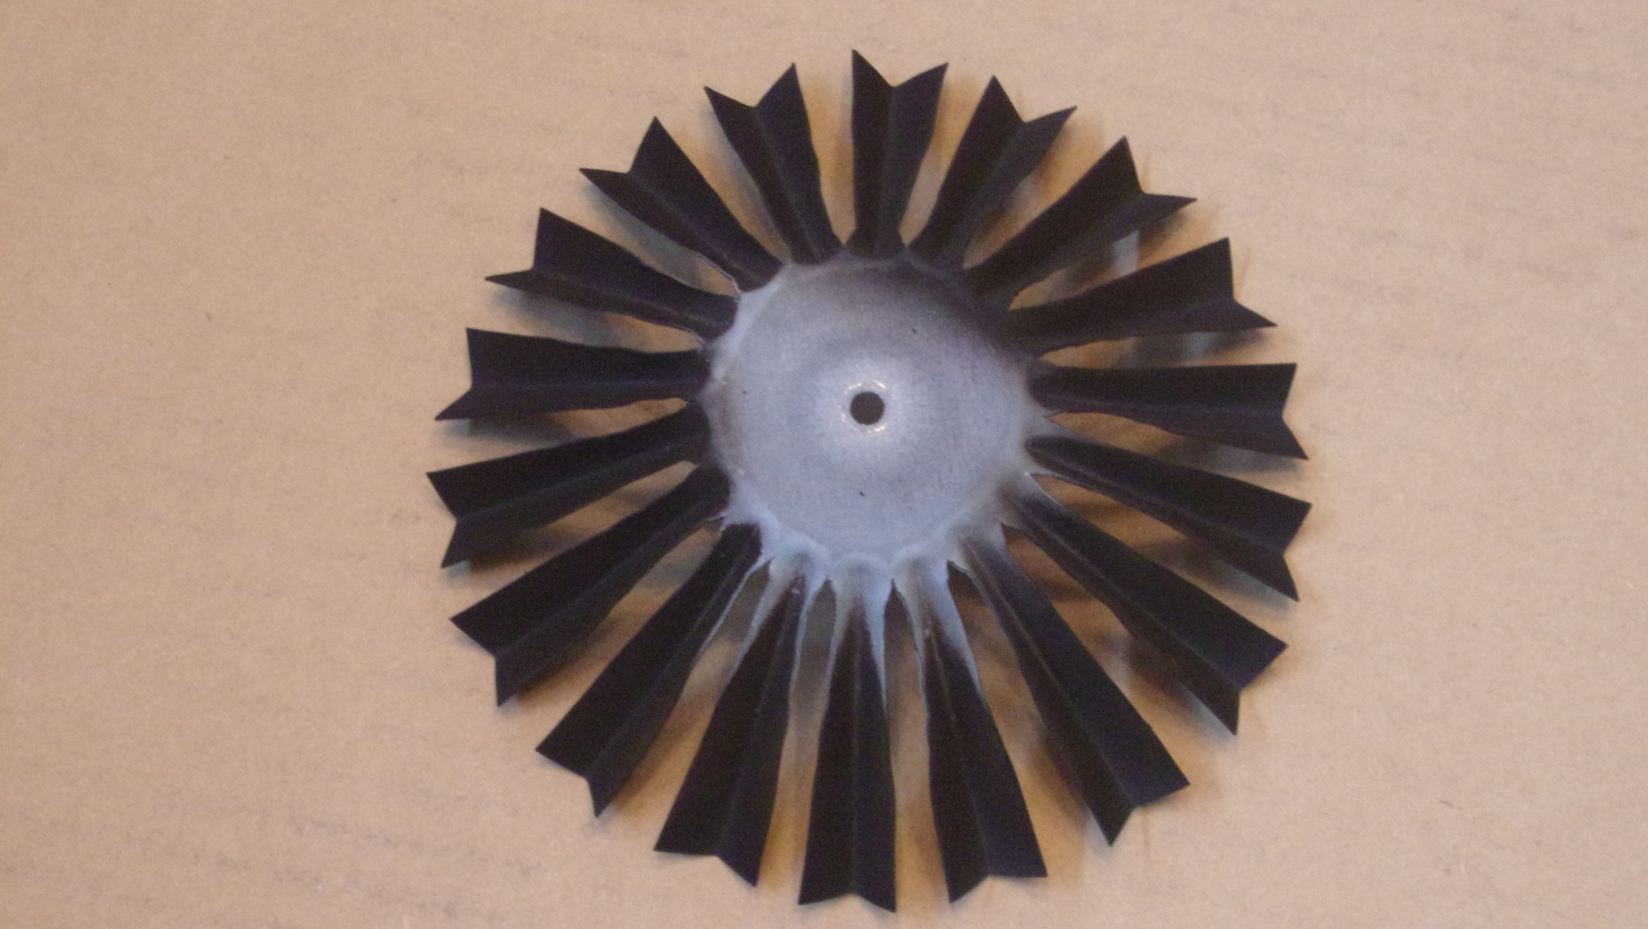

Secondary air can move up the legs of the wick and feed the wood gas from two sides, giving good mixing. This is the idea behind the radial slit design.

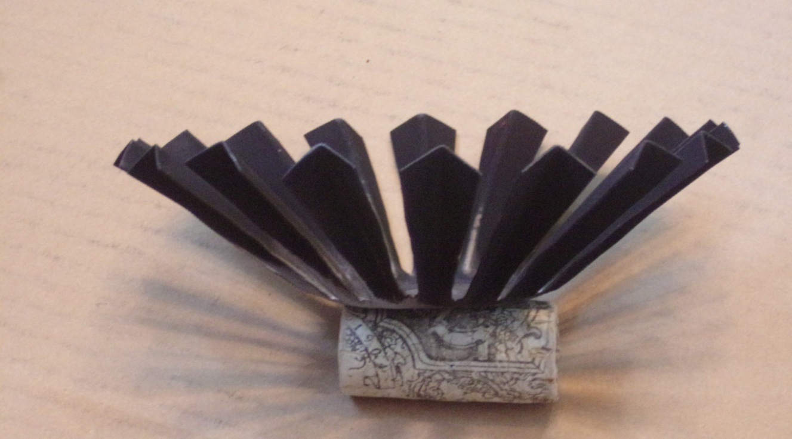

The wick is attached to the combustor so it comes off the stove with the combustor and does not interfere with fueling.

Combustor

Fuel/reactor chamber

The conical top of the fuel/reactor chamber allows enough space for gasses to pass, yet the flame has difficulty getting down through the slits. This turn-down technique works best if the flame stays above the wick.

There are three locations where the low power flame burns: The pilot, the wick, and above the pilot (this flame looks like an orange halo around the pilot flames).