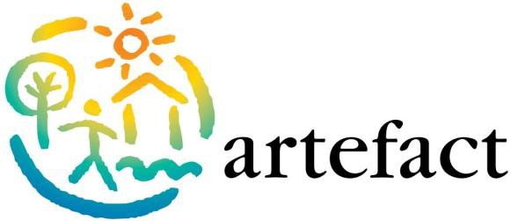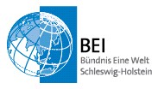

From pyrolysis boiler for Terra Preta

Household energy and horticulture - a topic in the north and Sud-Arbeit

Saturday, 11. - Sunday, 12. June 2016

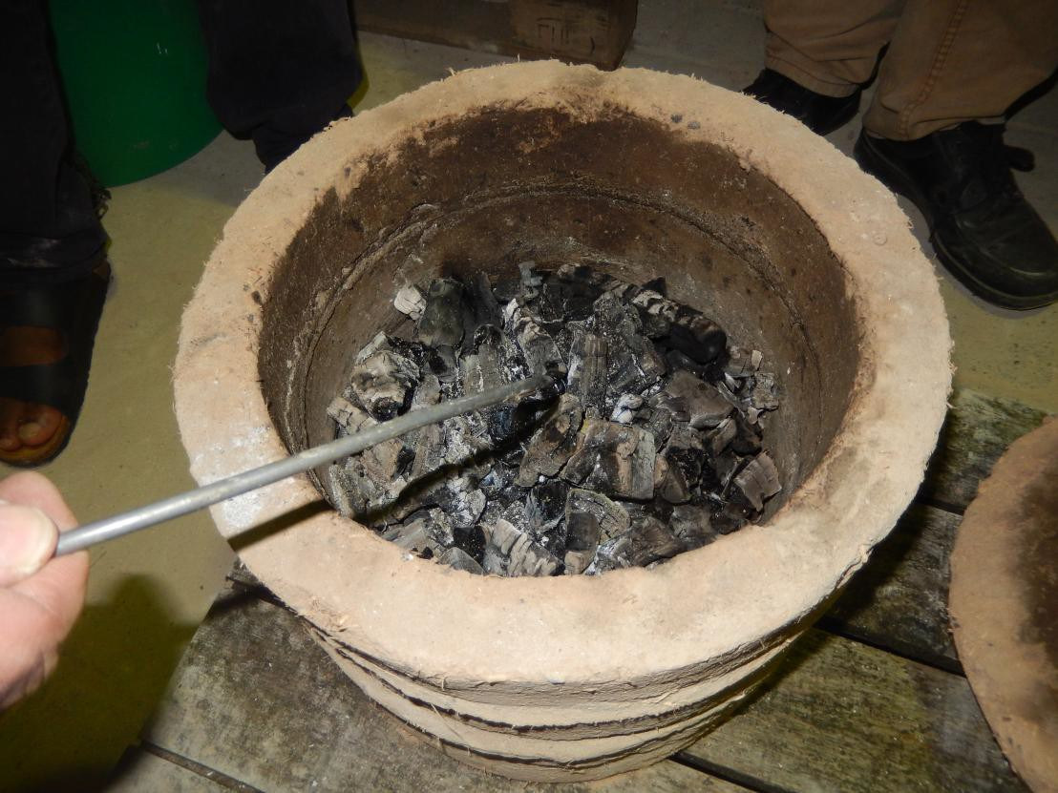
In artifact ( happiness Castle)

Saturday, June 11.
9:00 Firewood problem and cooking in Africa (Werner Kiwitt)
10:00 Pyrolyse-Lehmherdbau with focus on examples from Ethiopia
(marius Bierig)
11:15 hours From Mwoto to glow: Metal stove project from Uganda
(Sebastian Erdmann)
12:30 hours Lunch from the pyrolysis oven
13:45 hours Hands-on workshop for the assembly of the pyrolysis-
Metal stove ZamaZama
(Werner Kiwitt)
15:45 hours With ground regeneration, Terra Preta sanitation and wood gas technology to more productive rural areas (Prof. Ralf Otterpohl)
17:30 hours Visit /guide to Terra Preta production
In artifact and on Holnis/R.Bartsch

Sunday, 12 June
9:00 The horticultural project for agricultural practice:
Henning Knutzen
10:00 Excursion to the operation in Hurup : Experience and multipliers
12:00 hours Household electrical energy from the solar lamp to charger (Sebastian Erdmann, Werner Kiwitt)
14:00 hours Practice: construction of small chargers

Cost Contribution: € 85,-- incl. Sunday night in Nubian clay vaults maisonette (multi-bed rooms), Food
Single and double rooms with extra charge

For registration and further information for artifact Werner Kiwitt 04631-61160 info@artefact.de

In cooperation with: A World Alliance Schleswig-Holstein e.V.,
Walker Dam 1, 24103 Kiel, info@bei-sh.org

With the friendly Support of

