A Hypothesis of the
Two Stage Mixing of the Wonderwerk 316 TLUD-ND

(3-16 is the month that I first used this technique, introducing a major design improvement)
(Start at the bottom of this page like in the stove)
Clean, easy to control cooking
By these techniques the Wonderwerk stove, with adequate fuel, has burned very cleanly at all tested power levels. More testing with various configurations could allow the use of fuels with lower energy content.

Stator (stationary fan blades)
Swirling the flame with the stator gives a longer burn time for the gasses to finish burning, and concentrates the heat to support combustion.

Upper mixer (Venturi tubes)
Additional secondary air is rapidly mixed into the fire gasses at the upper mixer providing oxygen to combust the newly cracked hydrocarbon gasses and fractured carbon particulates. Most of the would-be particulates will burn.

Lower mixer (canopy)
Both mixers use a combination of draft, Venturi effect, and large contact area to rapidly mix the wood gas and secondary air.
Rapid mixing of gas and secondary air at the lower mixer produces the rapid burning of the easy to burn gases, H₂ and CO. This makes a region of concentrated heat in the confined space between the mixers. Long chain hydrocarbons in the wood gas pass through this hot region and are cracked forming shorter chain hydrocarbons which are flammable gasses. Particles of carbon are heat stressed and break into smaller, easier to burn particulates.
This method is dependent on rapid mixing and fuels that can deliver enough heat.

Pyrolysis wood gas
Pyrolysis gas is very dirty, containing large hydrocarbons and particles of carbon which are the makings of soot and smoke.
Wonderwerk turn-down requires controlling only the primary air with one simple and intuitive lever, making power level control easy for the cook.

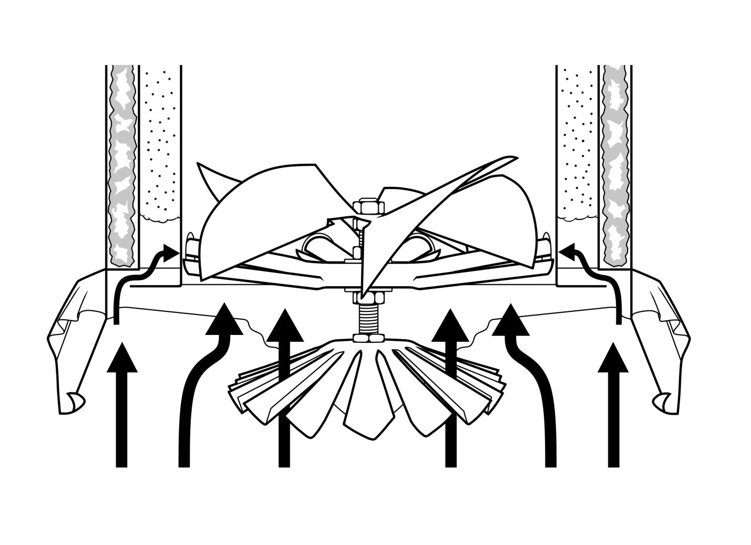
The long chain hydrocarbons are cracked in the hot region between the mixers, using the quick burning gasses to make the particulates easier to burn.
Drawing by Jacob Brown
The stator spins the flame to give it more time to burn and to concentrate the heat.
These devices placed in the flame path do increase flow resistance. They also speed the burning process creating more draft to overcome the added flow resistance.
The upper mixer adds air to burn the newly cracked hydrocarbon gasses and carbon particulates.
The lower mixer rapidly burns the easy to burn gasses H₂ and CO creating the concentrated heat necessary to crack the large hydrocarbons and carbon particles.
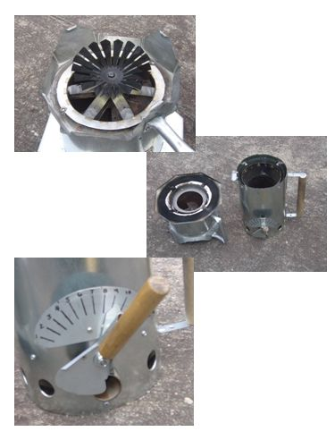
Thank you for considering my hypothesis.
Kirk H.
The primary air control lever is simple, intuitive, and easy to operate.
Combustor turned upside down showing the lower mixer (canopy), upper mixer (Venturi tubes) and the stator.
Drawing by
Jacob Brown
Combustor (left)
Fuel Reactor (right)
Combustor legs protect the canopy

