**Woodgas Cookstove Proposal for Haiti: Highlights**

Prepared by Paul S. Anderson, PhD [ Email: [psanders@ilstu.edu](mailto:psanders@ilstu.edu) ] 4 February 2017

Proposal: Woodgas stoves should be included in a significant way in future cookstove activities in Haiti, especially in the forthcoming Canadian-sponsored efforts.

1. This document is open to all readers, but is particularly directed to the Global Alliance for Clean Cookstoves (GACC) and to Global Affairs Canada (GAC) that are considering alternative plans for major assistance (said to be 50 million dollars) for **cookstoves in Haiti**. This information supplements what the GACC submitted to GAC in December 2016 as an initial design phase strategy.

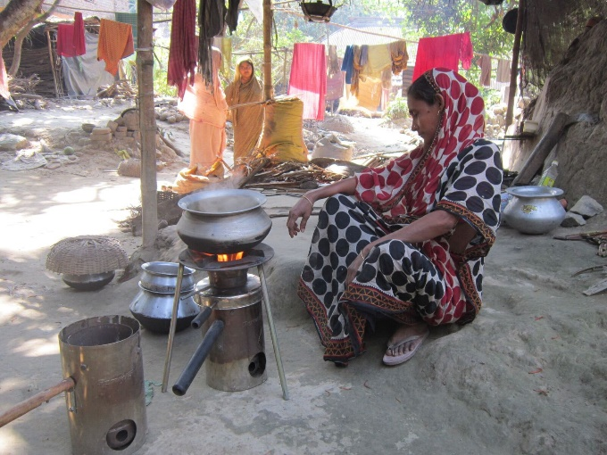2. Woodgas cookstoves (also called TLUD (tee-lud) stoves and micro-gasifier stoves) are rated as superior, cleanest-burning stoves that utilize dry biomass fuels [see joint publication by GACC and ESMAP (2015, Tech Rpt 007, figure 1)]. These are gas-burning stoves that make their own gases from dry biomass primary fuels. The TLUD stoves also produce significant amounts of charcoal. There are many designs, such as the stainless steel one in the photo which is made and used in India.

3. Wood as a renewable fuel in Haiti is not as scarce as is commonly stated; forests actually cover 30% of the country. See [www.envirosociety.org/2016/05/haiti-is-covered-with-trees](http://www.envirosociety.org/2016/05/haiti-is-covered-with-trees) . The “Haiti Cookstoves and Fuels Market Assessment: Preliminary Report” (GACC, 2016, page 38,) reports that in rural areas (which account for 45% of households), 72% of households primarily rely on wood fuel, (and 24% on charcoal). (72% of 45% is 32% of all Haitian households.) Over 700,000 Haitian households (HH) are burning wood as their primary fuel, and their stoves are very inefficient. Many other homes use wood fires frequently.

4. Based on usage of thousands of woodgas stoves in Deganga, India (see [www.drtlud.com/deganga2016](http://www.drtlud.com/deganga2016) ), the use of TLUD woodgas stoves in Haiti would reduce the net consumption of primary wood fuel by half, and simultaneously produce charcoal. In typical stove usage, that charcoal is approximately 800 grams per day per HH, or 30% of the energy value of the primary fuel. In other words, by changing to woodgas TLUD stoves, the wood-burning Haitian rural households (almost one third of Haitian households) could cut their fuel consumption in half AND produce substantial amounts of charcoal for use by the urban households or for other uses. The wood that was being saved could be used by another third of Haitian households while also producing more charcoal. All of this is internal and renewable in Haiti, without importation of fuel.

5. Traditional methods of charcoal production waste two-thirds of wood’s thermal energy while releasing undesirable emissions. Within a few years, all Haitian traditional charcoal production could be converted to TLUD charcoal-making applications (cookstoves and larger devices) which utilize that heat and still yield valuable charcoal. Larger devices include ovens, industrial applications, and water heaters for hospitals, hotels, and industry. The TLUD woodgas technologies can triple the useful energy from wood that is wastefully made into charcoal by current practices. A fuel industry can be built in Haiti, including job creation and the reduction of expenditures for imported fuels.

6. Woodgas stoves are shown to be well accepted when introduced in concentrated numbers (reaching “critical mass” for community support), as seen in the previously-cited Deganga Case Study. The experiences in India should be replicable in numerous areas in Haiti where woody fuels are found.

7. In addition to being quite clean-burning and using much less fuel for residential cooking, there are other potential advantages to woodgas TLUD stoves.

a. One is the option to use non-wood fuels, such as abundant agro-residues, maize cobs, pelletized grasses and stems.

b. Also, the charcoal produced can be used as biochar, a soil amendment with potential to increase food production. An intensive pilot study of biochar impact in Haiti could be incorporated into the Canadian-sponsored cookstove efforts. The 2015 PhD thesis of Dr. Roy Beckford (agriculture extension services in Florida) about “anthropedogenesis” (soils created by human activity) in Haiti substantiates these statements. [Abstract found at: <http://www.prescottsymposium.org/dissertation-presentations-2015/> (second in the list)].

c. Similarly, several aspects of the woodgas stoves lead to reductions of CO2-equivalent emissions. These carbon credits could be claimed by Canada, or be reverted to the efforts in Haiti to make the woodgas be essentially self-supporting (or income earning) once they are in use in the households. Dr. Anderson can provide further information about these options.

8. Note that woodgas stoves have their greatest appeal to the poorest of the population that is dispersed in the rural and most remote parts of the country. Therefore, TLUD woodgas stoves are quite complementary to the trend toward LPG stoves that relate best to urban households which are supported by modest incomes and local infrastructures which better enable the LPG stoves’ servicing and fuel supply chain.

9. Therefore, it is proposed that woodgas TLUD cookstoves be included in the Canadian-sponsored efforts in Haiti. Initial support can be modest (appropriate to the tasks of demonstrating what can be accomplished), followed by accelerated efforts to support 100,000 woodgas stoves by the end of 2018, and 50% of all Haitian households within a few more years. Related goals include establishment of a renewable-fuel supply-chain, significant climate-friendly benefits, and possible soil and food improvements with anthropedogenesis. The objective is the transformation of Haiti from within.

Thank you for considering this proposal.

Paul S. Anderson, PhD, Email: [psanders@ilstu.edu](mailto:psanders@ilstu.edu) ; Websites: [www.drtlud.com](http://www.drtlud.com) and [www.woodgas.com](http://www.woodgas.com) ; Office phone: +1-309-452-7072 ; Mobile phone: +1-309-531-4434

Bio-sketch: Paul Anderson retired in 2003 after 30 years of university teaching (geography and mapping) on four continents. He has worked full-time on TLUD woodgas micro-gasification since 2001 and is internationally recognized as “Dr TLUD”. His focus is on sustainable appropriate cookstove solutions for assisting very poor households. He is available to assist large cookstove projects that could be proposed by substantial agencies, but he is not seeking administrative authority. His expertise extends far beyond what is discussed in this short proposal.