Testing stove Model Nr. MN4 (with new improved bridge)
Date: 05.09.2017
Stove manufacturer: Altynbek
Place: Bishkek, Alybek workshop located near the city Heat Station.
Fuel: Kara-Keche coal
Testing time: From 16:55 to 17:42

Description
Stove Model Nr. 4 has a ceramic firebox with one cooking plate above it. There is one heat exchange chamber inside the stove. This stove model fuel is local Kara-Keche coal, crashed into small pieces from 10 to 30 mm. For this test we changed the bridge of the stove and put additional bricks between the combustion chamber and the outside wall of the stove to protect the coal of roasting.
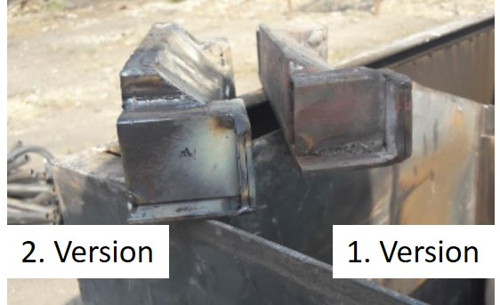  Figure 1: Two versions of the bridges | 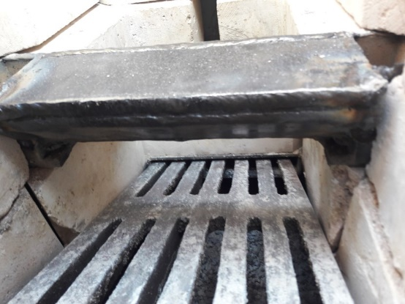  Figure 2: Bridge inside the stove

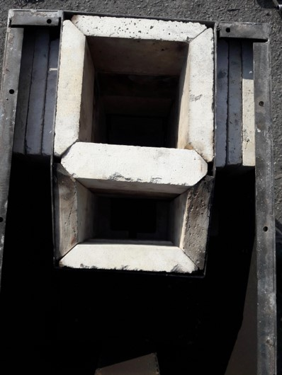  Figure 3:Top view of the additional bricks | 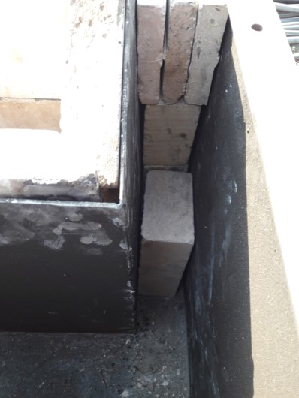  Figure 4: Additional bricks

In order to lit the fire we put into the firebox a layer of small pieces of Kara-Keche, above it small chopped wooden sticks. Around 5 minutes after ignition the smoke in the chimney disappears and fire stabilizes.
After 13 minutes the surface temperature of the sides of the stove was between 52°C and 101°C.
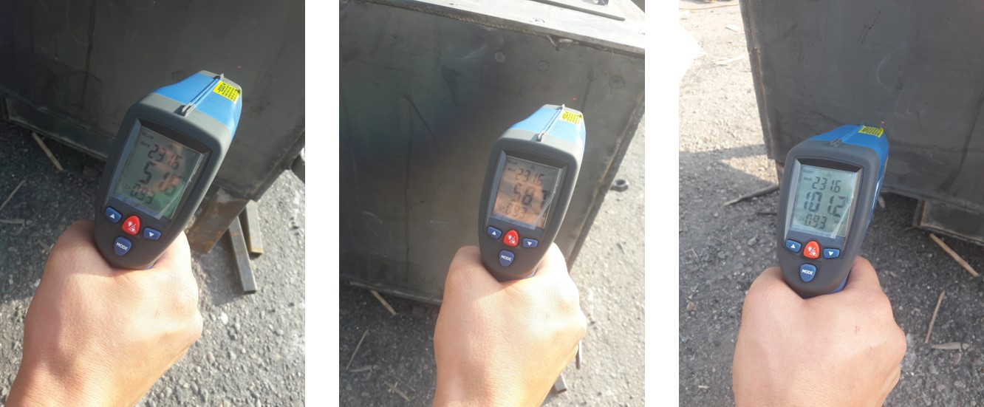
Figure 5: Surface temperature of the sides
After 30 minutes the coal in the hopper had a temperature of 60°C on the top.
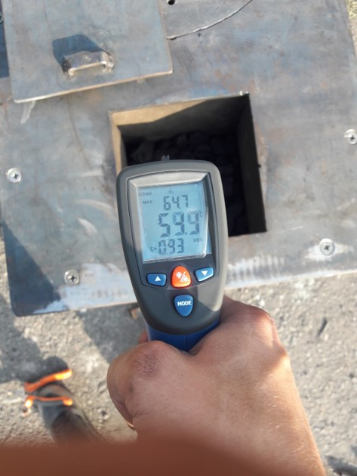
Figure 6: Temperature of the coal in the hopper after 30 minutes
Shaking of the iron grate after 40 minutes, adds fuel to the fire and causes some visible smoke coming out of the chimney for a period of 7 minutes. After 47 min 6,5 cm of the coal were burned. (bunker: 16,5x16,5cm)
The next day (after 17h) the ash in the stove was completely white and the bricks were slightly warm. For the whole burning time, without shaking the grate, there was no smoke.
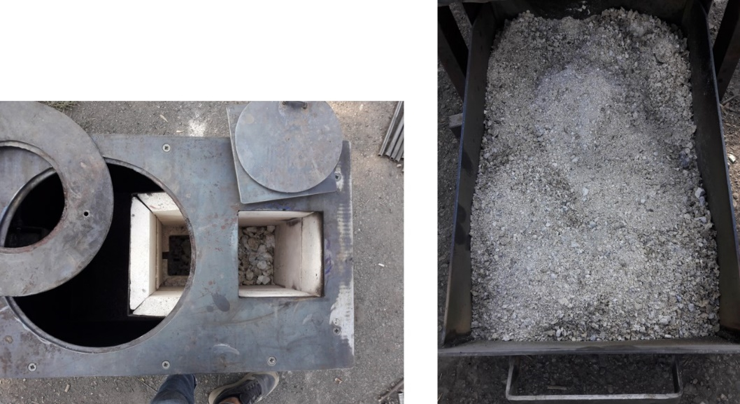
Figure 7: Ash after burning
Stove | Eff | CO/CO2 | Exit temp. | Average Excess air
Model MN 4.4 v2 from the Altynbek welding workshop | Low – 94,4%  High – 96,4%  Avarage – 95,7% | > 0,04%  < 0,31% | ~120 °C | 77,9%

