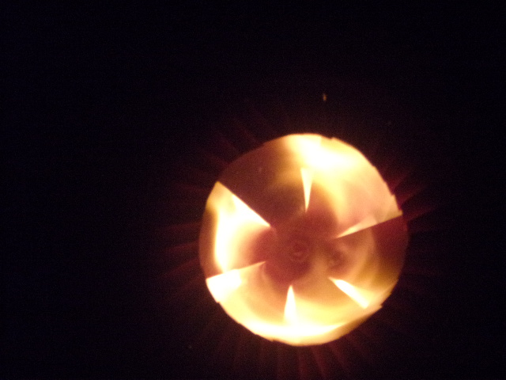

The stationary fan, adding burn time

A stationary fan blade swirls the flame giving it more time to burn, and also compacts the flame to keep it hot.