Three Hour TLUD

This stove was designed to give a three hour burn time at a power level of 5 to 6 kw. It sends the exhaust out the side for use in an existing plancha for a project in Guatemala. It can be modified for a pot stand or griddle to cook on top of the stove itself.

Proper testing at Aprovecho has been delayed by Covid 19.

The flame path is in red and the secondary air paths are in blue.

The in and out flame path gives the flame more time to finish burning than a straight up path.

,

Here, air is introduced to burn the newly cracked flammable gasses.

Pellet Fuel

Additive burners work together:

The pilot holes are a small burner to support a small flame.

The narrowed rim of the fuel chamber is a medium burner to support a medium flame.

The lower cone is a large burner to support a large flame.

The upper cone is a clean-up burner to burn cracked hydrocarbon gasses.

This area is where the heat is concentrated forming the heat reservoir. Tars are cracked into flammable gasses as they pass through this heat reservoir.

At this point the wood gas, having hit the cone shape, is spread thin, increasing the surface contact and reducing the depth of penetration between the air and wood gas. Also, the wood gas accelerates here, and the pressure is lower (by Bernoulli’s principle), increasing the pressure difference between the wood gas and air and so the force pushing them together. All of this enhances mixing, rapidly burning the easy to burn gasses and forming a heat reservoir which can crack the long chain hydrocarbons.

Shown is the combustor with the top removed to show the flame. With the top in place the hot gasses will go over the top of the inner cylinder, down the anulus opening and out through the chimney.

Shown is a moderate power level flame (~5-6 kw). Increasing forced primary air can considerably increase the flame size and power level. Forced secondary air is not required because the burner is good enough that it can burn the extra wood gas. Too much forced primary air can make a flame so hot it could damage the stove, and yet produce no smoke to warn the cook. A small fan is appropriate. The proper size for the fan will be determined at Aprovecho. Note no soot on this third burn in the stove.

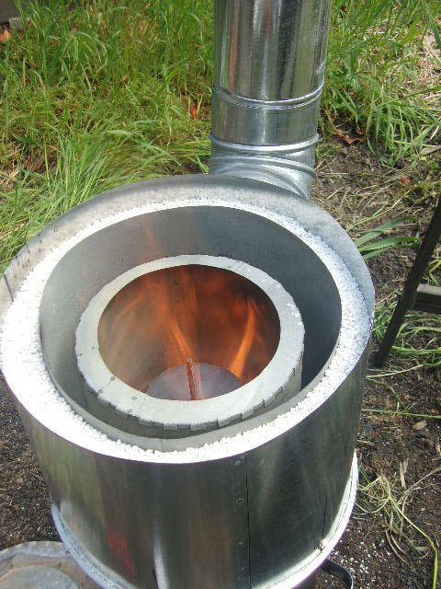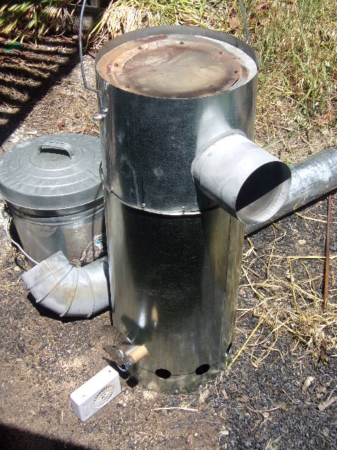

Fuel type: soft wood pellets

Fuel load: 7 kg (15.7 lb)

Burn time: 3 hr 11 min

Power level: ~6 kw

Smoke: none

Soot: only nonflammable ash

Char: saved, not burned

Turn-down: stable from low natural draft to high forced primary air

This view shows the entire stove. Visible are the chimney connector (Designed to feed an existing plancha for a project in Guatemala), the secondary air entrance holes, the primary air control lever, and the small plastic fan I am using for forced primary air testing.

Dimensional Drawing

Measurements are in Centimeters

.6 all-thread with nuts is supported by the bracket, and holds the cones in place.

13

Combustor in pink color

.6

,

19

24.3

12.7 dia.

9

19

9

1.3

Bracket and concentrator ring: see page 4

5.7

2.5

10

1.3

1.3

17

2.5

3.8

12

1.3

1

35.6

40.6

8 holes, .5 cm diameter, evenly spaced; supports the low power flame.

2.5

Lower cone and disk: see page 5

56

19

5

30.4

The bracket is made of three strips of 1.3 cm wide, sturdy stainless-steel sheet metal. The screws that hold this bracket to the combustor also hold the concentrator ring 1.3 cm below the combustor, with the bracket acting as a spacer.

14.7

The metal strips are bent at the ends to form holes for the screws.

The center remains open to accommodate the all thread rod.

Spot welds hold the bracket together

11

The concentrator ring enhances the inward flow of the flame, helping to concentrate the heat and crack the tars into flammable gasses. It is placed so that secondary air can pass above it to burn the newly cracked flammable gasses.

11

25

It is very important that the lower cone remain level to avoid a one-sided flame. It is supported by a disk to keep it straight. The disk may be mounted adjacent to the cone or at the top of the short cylindrical section.

OR

This part can be made of a ceramic for a longer life span

The best conditions for mixing the wood gas and secondary air are at the outside edge of the cone. The short cylindrical section holds the wood gas at that best location for a longer time to increase mixing.

Operated as a natural draft stove, a full 3-hour load of fuel will have to much flow resistance for the primary air to effectively rise through the fuel, resulting in a very low power level. Forced primary air is needed to get higher power flames. The power level can be considerably increased with stronger forced primary air. The burner is good enough to burn the extra wood gas. No forced secondary air is needed.

A smaller fuel load can be operated as natural draft; the fuel must however be raised to the top of the fuel chamber on a raised grate. A simple grate and support stand system works well for this.

A small load of fuel at the bottom of the fuel chamber allows the gas to cool, and burns dirty with no turn-down.

BASE AND FUEL CHAMBER MOUNT

The base ring fits snuggly inside the outside skin of the stove and is attached to the skin with screws. This gives strength to the bottom of the stove. On top of this ring are attached two sturdy metal strips with holes drilled for the screws attached to the bottom of the fuel chamber to pass through.

Fits snugly into the outside skin of the stove.

Top View

Side View

Base ring is made of 1.8 cm diameter electrical tubing

Attach with screws or weld

Four Machine screws support the fuel chamber on top of the base ring. This arrangement allows the fuel chamber to be adjusted up and down, and angled to be centered in the stove. Mounting the fuel chamber at the bottom keeps the sides of the chamber free of mounting brackets, allowing simple installation of insulation and heat reflectors.

Fuel Chamber

The base ring strengthens the stove bottom and acts as a sled so the stove may be slid on the ground to disconnect it from the plancha for emptying and fueling.

The old stove needed to have the combustor held above the fuel reactor while starting the fire. This stove does not need this, the combustor can be put down on the fuel reactor immediately upon igniting the flame. The legs need to be tall enough to give clearance to the cone when the combustor is set on the ground, and angled to center the combustor as it is placed onto the fuel reactor.

Combustor

Fuel Reactor

The lower handle makes it easy to turn the stove over to empty the char. Lifting the whole fuel reactor is safer than removing and handling the hot fuel chamber, since all hot parts remain insulated inside, lessening the possibility of burning someone.

Combustor

Fuel Reactor

An alternative to the legs is this design which adds a shield that protects the stove body and helps keep the handles cooler.

Four brackets are needed, though only two are shown here.