An Injection Mixing technique for burning wood gas
Kirk Harris 2020
The injection burning technique emerges from an examination of the pressure variations in the stove. It is not a new technique, being used in both the Pico Pe stove and the Champion stove. It is not optimized in either stove. The Champion stove begins with secondary air/gas injection mixing around the rim of the reactor chamber and then switches to the concentrator mixing technique.
The initial pressure difference between the stove gasses lower pressure inside the stove and the atmosphere, is provided by buoyancy. This is the pressure difference that propels the primary and secondary air into the stove. Subsequent pressure variations can be caused by various processes such as; vaporization of wood gas from the fuel fills some of the lower pressure, combustion of the gasses creates expanding gasses to raise pressure but also creates more heat and buoyancy to lower pressure, Dr. Ron Larson describes that chemical combinations create lower pressure when two molecules combine to form one (C + O₂ = CO₂ and H₂ + O = H₂O), back pressure from flow resistance raises pressure in the region preceding the resistance, the Venturi effect from changing the velocity of the gas through or around an object in the flow stream can lower pressure in that region, directing air flow directly at the wood gas instead of merging them in parallel can increase its impact pressure, and finally cracking long chain hydrocarbon particulates into short chain flammable gasses, which take up more space, can increase the pressure, but also buoyancy. It does get complicated.
Included are some drawings which explain, using pressure variations, why some TLUD-NDs can smoke when turned up and extinguish when turned down. This lays the ground work for understanding the Injection mixing technique.

This design for a TLUD-ND cooking stove raises some concerns around pressure variations.
The drawing shows how the wood gas in the center gets no air, the depth of penetration for the secondary air to penetrate the wood gas is too deep, and the pressure difference too small. The concentrator is intended to force the gasses together and/or create enough turbulence to mix the gasses in the center, molecule to molecule.

A second concern is that the concentrator creates back pressure in the wood gas.
As the power level is turned up more gas is being produced and forced up against the flow resistance of the concentrator, increasing the back pressure still more. The pressure difference between the atmosphere and the wood gas is decreased (P_{atmosphere} – P_{stove} = P_{difference = r}P). The _{r}P is the force which propels the secondary air into the stove, and less _{r}P means that less secondary air enters the wood gas. More wood gas and less secondary air should make the stove begin to smoke, which is what we see in tests and use.

As the power level is turned down less wood gas is produced and pushed against the flow resistance of the concentrator, reducing the back pressure. The pressure difference, _{r}P, is increased propelling more secondary air into the wood gas. With less wood gas and more air, the excess secondary air cools and dilutes the wood gas extinguishing the flame. This we see happening in tests and use in the field.
This is backwards, more gas needs more air and less gas needs less air.

If the secondary air holes are placed above the concentrator the pressures work better. Whereas back pressure raises the pressure below the concentrator, the accelerated gasses above the concentrator create a lower pressure by the Venturi effect.

As the power level is turned up more gas is being produced and the velocity above the concentrator increases. By the Venturi effect the gas pressure above the concentrator is decreased still more. The _{r}P between the wood gas and atmospheric air is increased, pushing more secondary air into the wood gas. The increased wood gas has more secondary air and should burn cleaner. However, there is very little surface contact between the air and wood gas, the depth of penetration is quite deep, and the wood gas is moving too fast for much air to mix in, so it would still be smoky.

Dean Still at Aprovecho Wood Stove Research Center, discovered a solution to this problem while working on a different stove concept. He directed the flame gas through a nozzle forming a stream of flame. He then placed a blunt body where the flame stream would hit it and spread around it. He told me how this improved his results, and upon examination I could see that it fit with the pressure concepts.
At the outer edge of the blunt body, the flame gas is spread into a thin film, and again accelerated. We now have Venturi increased _{r}P, large surface contact between the wood gas and secondary air, and shallow depth of penetration. Here is where the mixing is at its maximum. The flame gas is moving fast but the air has more _{r}P to penetrate it, a very shallow depth to penetrate, and the large surface contact allows penetration over a large area. This is a very fast and thorough mixing technique.
Because this mixing technique uses pressure differences to push the gasses together, I have been calling it “injection mixing” (Injection: noun: the forceful insertion of a substance under pressure). To distinguish it from forced air injection I will refer to it as “passive injection”. Also, I have referred to “rapid mixing” in earlier writings, and how it is necessary for a super clean burning technique. This mixing technique is a rapid mixing technique.

Note the flow is laminar. It is not designed for turbulence.

Air

The drawing is elongated vertically for clarity.
A third concentrator at the top of the stove reflects heat back down to help contain the heat during the final stage of combustion and also directs the hot exhaust gas to the center for more contact time with the cooking vessel.

Passing the flame around a second blunt body again accelerates it and lowers its pressure by the Venturi effect. Secondary air that passes around the outside of the second concentrator mixes into the flame gasses to burn the newly cracked hydrocarbon gasses. The velocity of the gasses at this point is high enough that a small blunt body can push the flame gas outward.

Concentrating the flame again through a second concentrator creates a concentration of heat that I call a heat reservoir. Long chain hydrocarbons must pass through this heat reservoir and so encounter the necessary conditions to crack them, a high enough temperature to drive the cracking process, and enough quantity of heat to feed the endothermic cracking process. The heat from burning the easy to burn gasses is used to crack the hard to burn tars, and make them easy to burn.

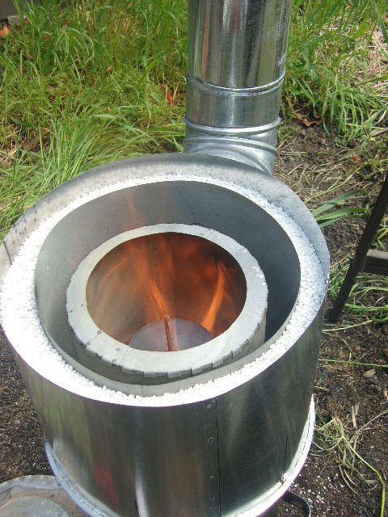
This is a photo of a stove with the top plate removed. This combustor has a side exit when the top is on (note the chimney), but the standard top exit works as well. It shows the smaller second blunt body spreading the flame and the third concentrator. The insulation around the outer wall is pearlite.
Note that the flame is hot all the way till it finishes burning, contributing to a clean burn. It has plenty of air to complete the burn, and need not exit the top of the stove to find air above the stove like some stoves.
This stove is designed to allow lots of secondary air in, not following common ratios of primary to secondary air. The technique is very fast mixing/burning and so actually requires more secondary air early on.

